**Advanced class diagram and sequence diagram:  
Composition, Generalization, and Service Controllers**

Objectives:

* Create a class diagram and a sequence diagram with Composition and Generalization.
* This is an individual lab.

Complete a Visual Paradigm model as per the following requirements. Copy your diagrams to this Word file and include both the Word and the source .VPP files in your submission.

**Case Study:**

A fitness company would like to build an information system to support their business. As a business IT analyst, you have interviewed the fitness company’s owner and documented the following three use cases. You will help them to model a small portion of the system by using class diagrams and sequence diagrams. Currently the fitness company holds 10 fitness centers across the GTA area.

**Use Case: Create Fitness Membership for New Member**

*Business rule: A member can have a few memberships but only one can be active. When a membership expires then the member can renew it or leave it as expired.*

*Precondition: The actor has logged in the system.*

|  |  |
| --- | --- |
| **Actor (Office Administrator)** | **System** |
| Requests to add a new member. | Displays entry area for member information (member’s first name, last name, date of birth, driver license number, email address, phone number, etc.). |
| Enters member’s information accordingly, and requests to save. | Generate a member id for the member and saves the new members’ information. Also displays a list of membership types including name, description, and yearly cost for each type. The company provides three variants of membership types: Silver, Gold, and Diamond. The Silver membership can enjoy all the facilities at the center. On top of the silver membership, the Gold membership can choose one of the relaxing rooms as his/her own relaxing room as long as the membership is valid. On top of the Gold membership, the Diamond membership can choose one of the parking lots as his/her reserved parking lot. |
| Chooses one of the membership types. | If the chosen membership type is Gold or Diamond, displays all the relaxing rooms and parking lots to choose. (Gold membership can only choose a relaxing room since no parking lot is included). |
| Chooses one relaxing room for Gold membership, and also choose one parking lot for Diamond membership. | Requests to confirm. |
| Confirms adding the membership type to the member. | Sets membership status to active. Generates and assigns a membership number to the membership. Set current date as the membership starting date and set the date after one year as the membership expiry date.  Saves the member and the membership to the database. |

**Part 1: Class Diagram**

Create a Class Diagram based on the case study background and use case scenarios above. Demonstrate that you understand Composition and Generalization, where applicable.

**Part 2: Sequence Diagrams**

Create an object-level Sequence Diagram for the use case given above. Demonstrate that you understand how to handle Composition, generalization, and the appropriate use of Service Controllers in sequence diagrams, where applicable.

**Part 3: Operations**

Each message in the sequence diagram is an operation assigned to your classes (including controllers). **Update each class with its operations.** Remember, returns are not operations.

For example:

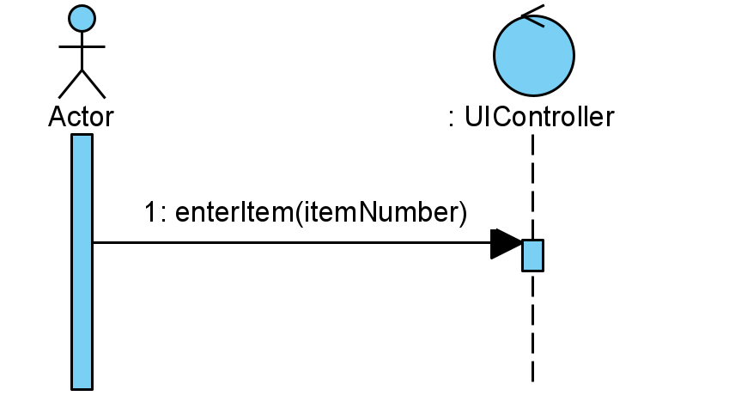The UIController has the operation: *enterItem*.

*enterItem* ends at the UIController lifeline and therefore belongs to the UIController. The Actor calls the UIController’s *enterItem* operation.

To add operations to classes in Visual Paradigm, right click on the class in the class diagram and select *Add*, then *Operation.*

***Name: Mehtab Singh Jagde***

***ID: 119003226***

***Mail: mjagde@myseneca.ca***

Class Diagram:

Controller Diagram:

Sequence Diagram:

